Issues found on MFI
- Sometimes while login/register login via telegram not works

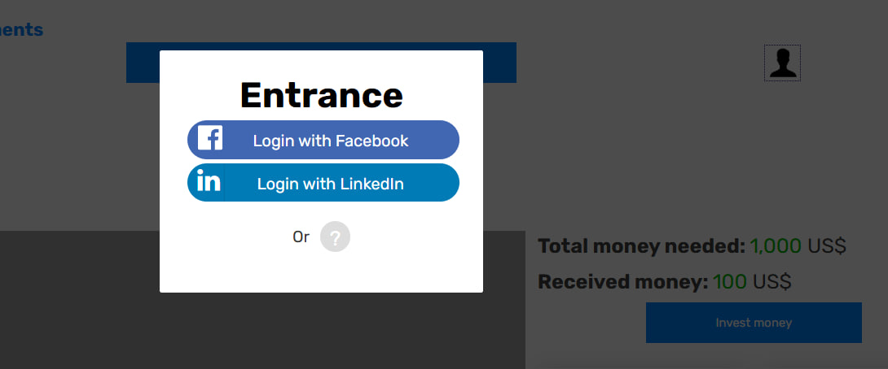

- User is not logged in still he able to invest money

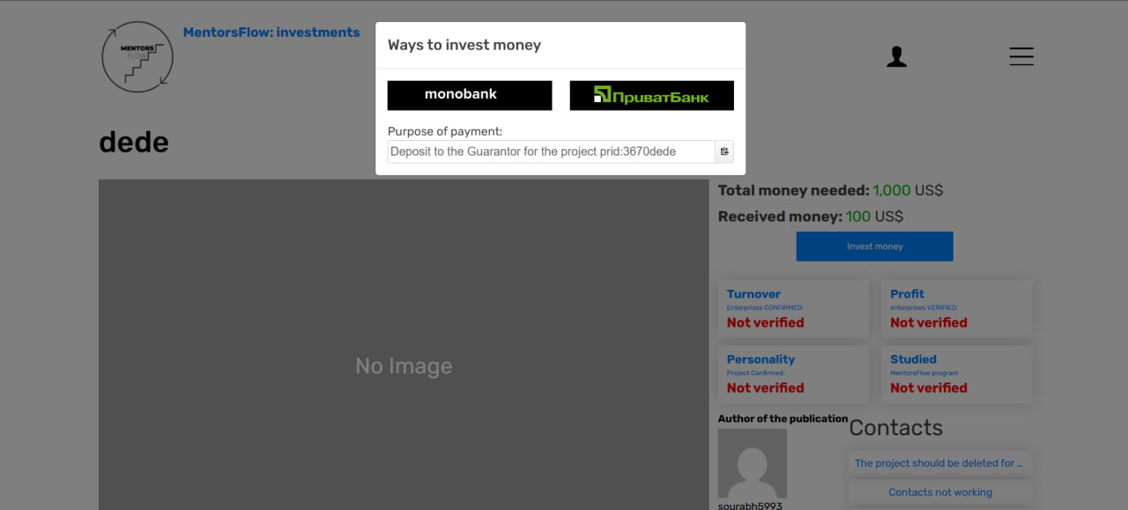

- I am trying to register new user still it is showing me login as Sourabh

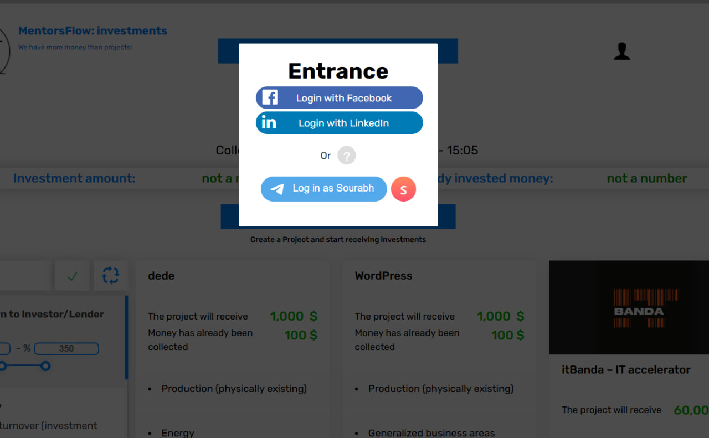

- Inside project in contacts section, contact details are not showing on click of show button.

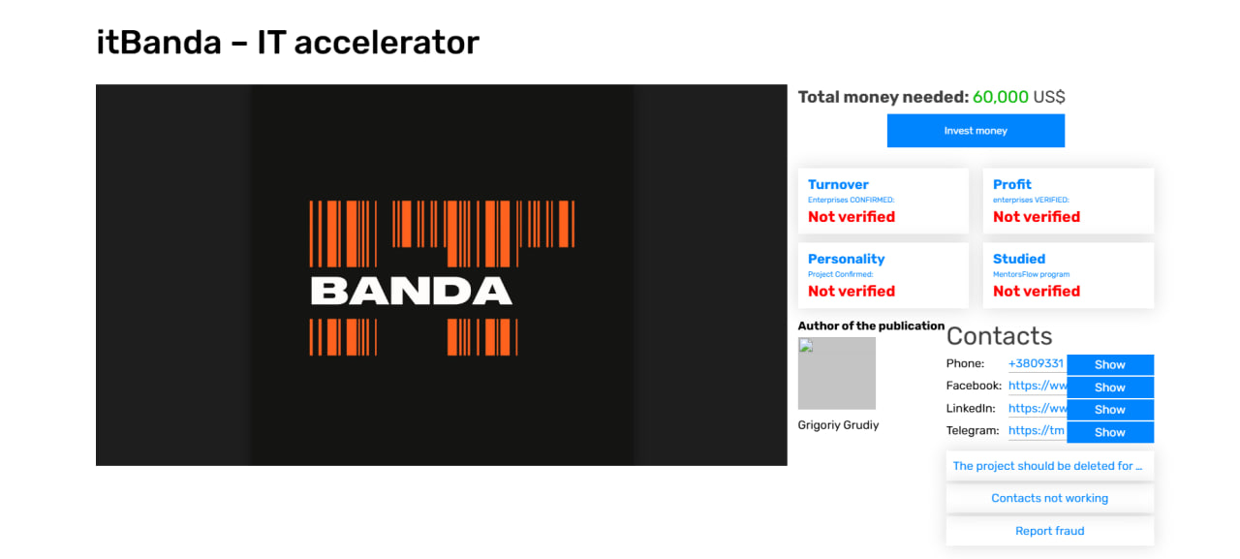

- here both, profile setting and to personal account do the same tasks
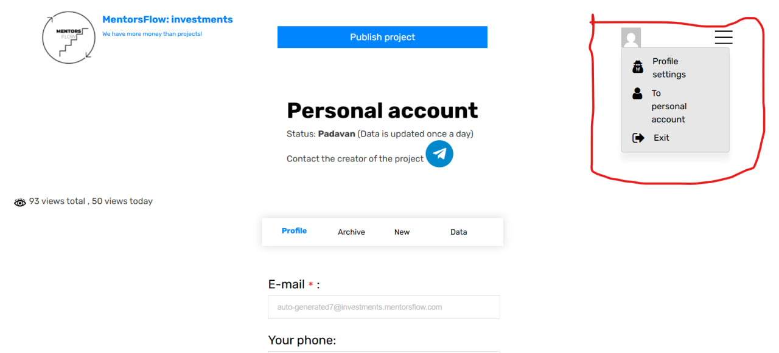

- Languages are not searched
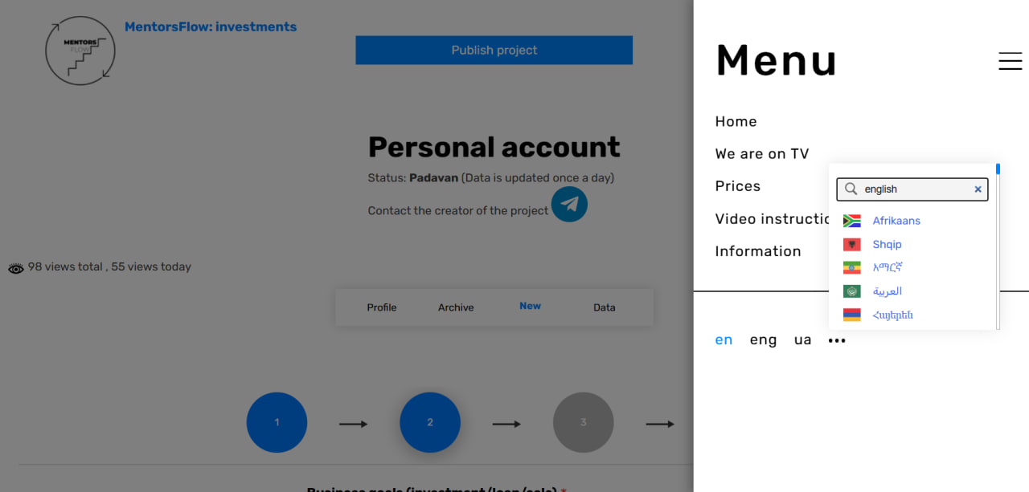

- Creting project, it gives validation message for step 1, but not for step 2

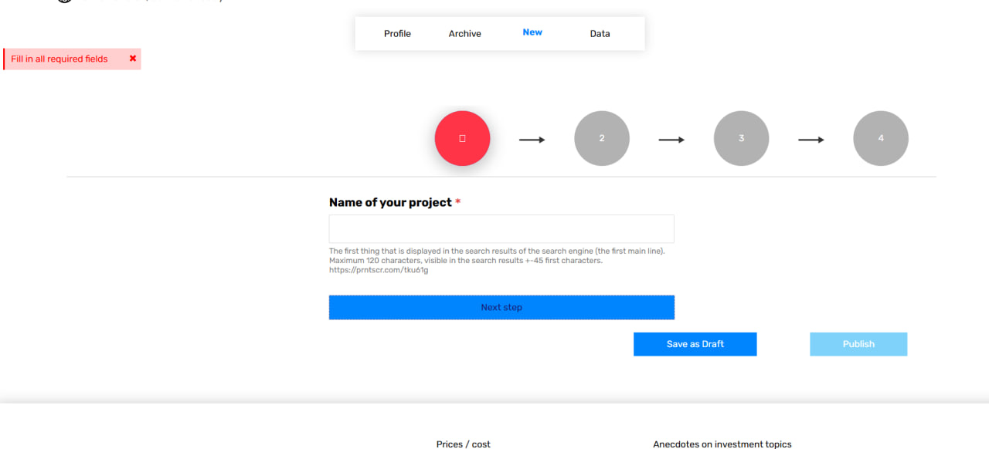

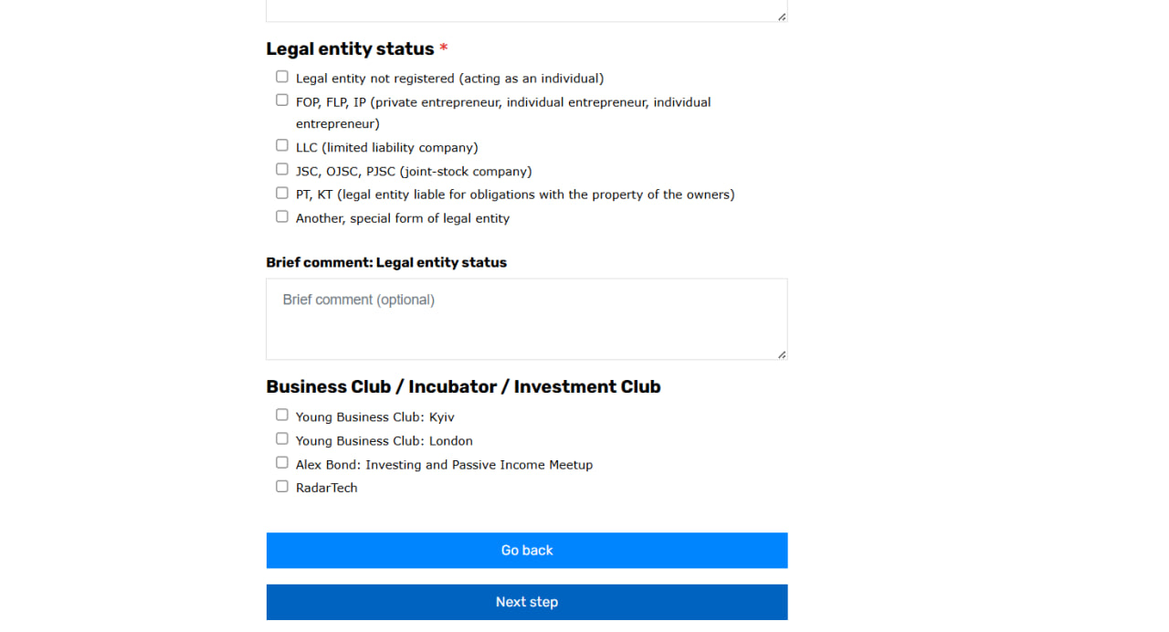

- During project creation, I am at last step still the publish button is disable.
Above we already have one publish button so we can remove it.

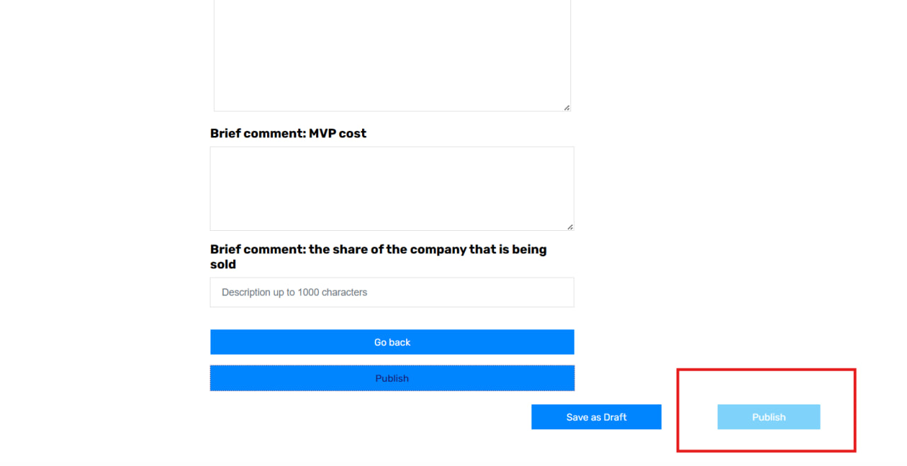

- If I select a particular filter then the selected filter is display at at top.
But when I deselect the filter still the previous selected filter display as selected

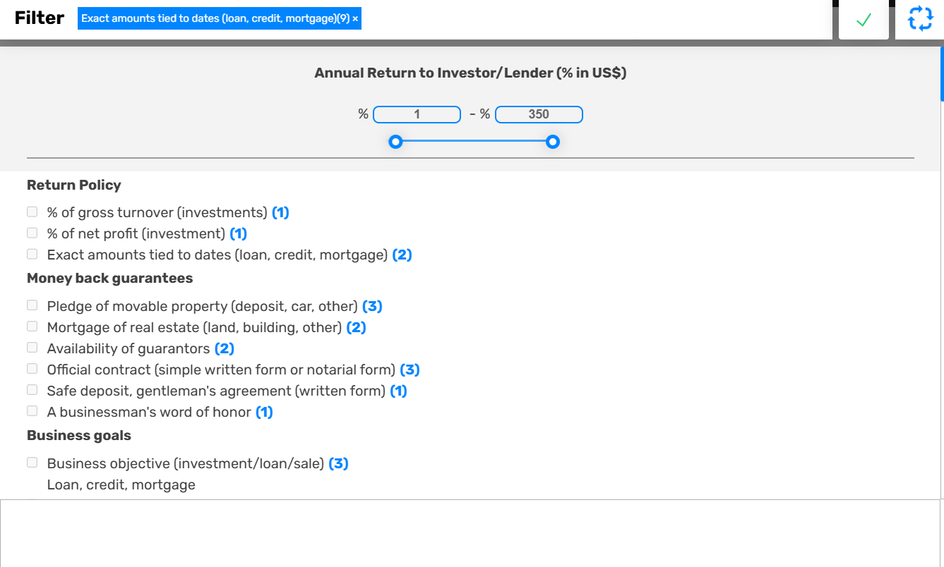

12. UI design breaks for Project description
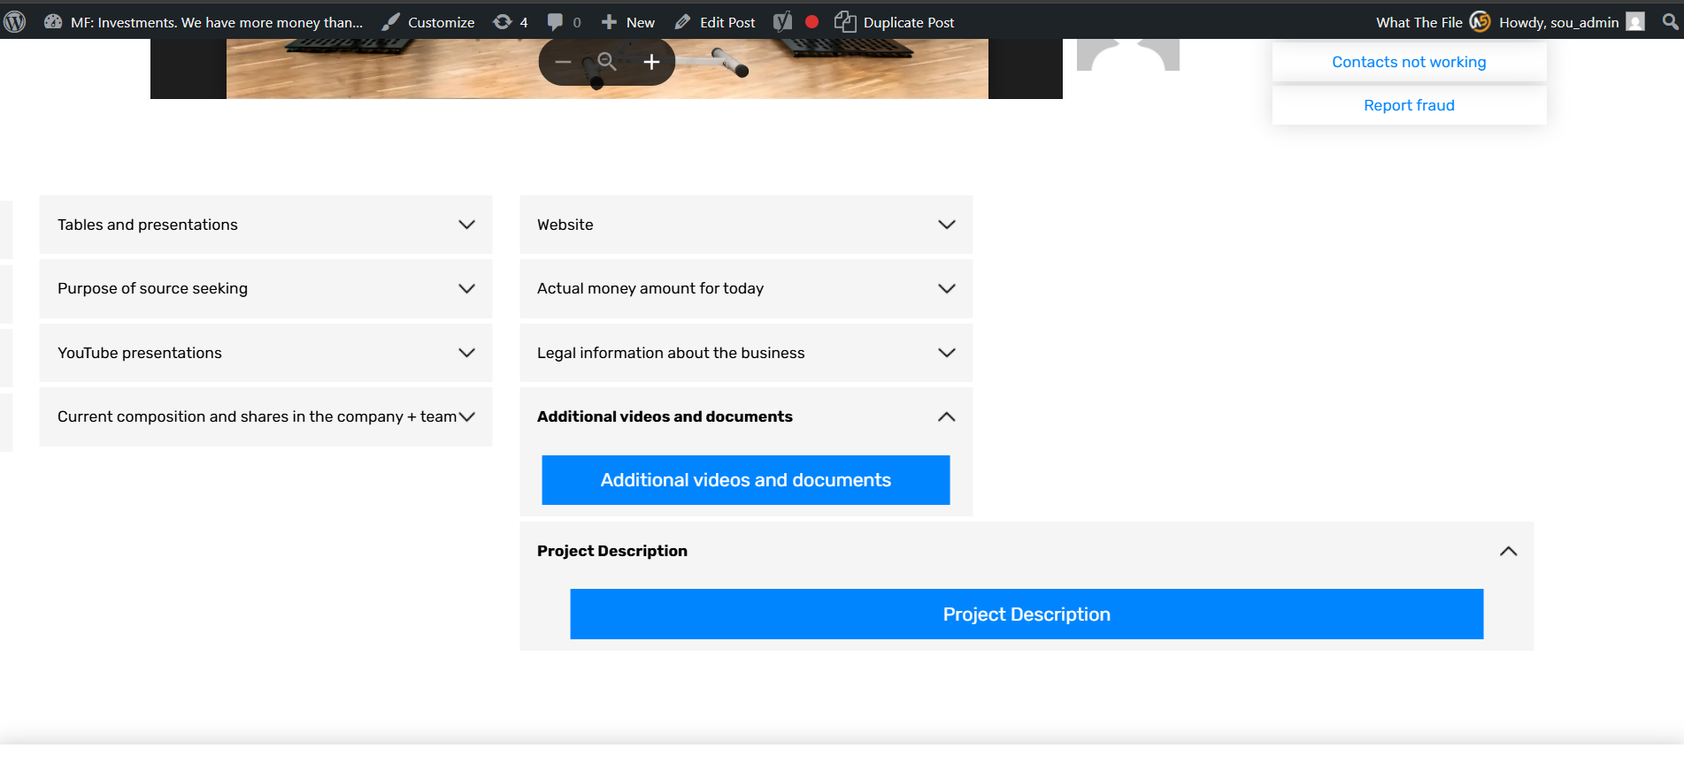

- If I apply multiple filters still it shows only one

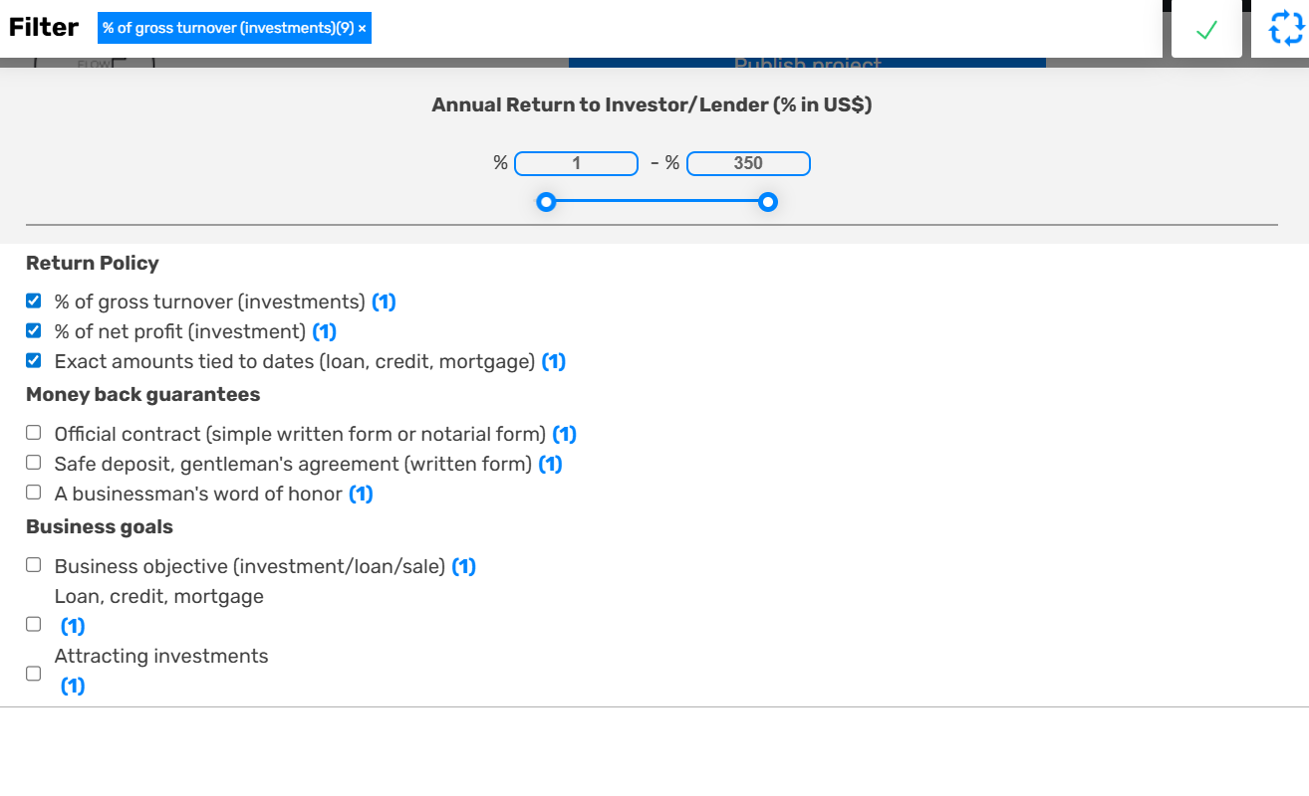

Some Suggestions

- Add clear navigation menu with sections like Browse Projects, Publish Project, About, Login/Register.

- Implement visible registration/login buttons on the homepage.

- No preview of project form – show a read-only example to show project details before publishing.

- Create a clear project submission workflow with a "Submit Your Project" call-to-action.

- Add a comprehensive filtering system with dropdowns for category, investment amount, location, stage, etc.

